**CARS DATASET PROJECT**

**Jaswanth Sai Damarla**

***AIML,TDP Empowerment centre,***

***Mangalagiri,Guntur(Dist),***

***AP(State)***

**Abstract** – This document is mainly consist of four cars datasets classification and those companies are Audi, Rolls Royce, Tata Safari, Mahindra Scorpio.In this we have taken and discussed about the cars companies in our report and this we have taken different image datasets to predict the cars

companies dataset classification.

1**.INTRODUCTION** – Cars are useful transportation in our daily life. These days cars are prestigious things . The cars look very similar . Audi, Rolls Royce, Tata Safari, Mahindra Scorpio these are very trusted companies we have found and moreover in this we are discussing about four companies: Audi, Rolls Royce, Tata Safari, Mahindra Scorpio.The development of automatic technologies for assessing automotive damage has shown to be very advantageous because it requires less manual labour and considerably increases the effectiveness of damage inspection. In recent years, the vehicle insurance business has seen a significant uptick in the integration of deep learning in car damage assessment .When processing routine claims, insurers can save a lot of time, money, and manpower by automatically identifying small exterior damages like broken glass or broken glass. To correctly locate and categorise the aforementioned sorts of damage, considerable emphasis is being paid to research that focuses on damage assessment

for vehicles.

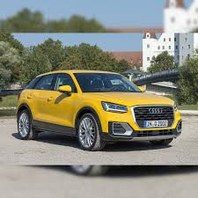 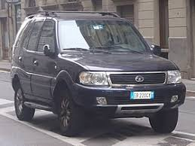

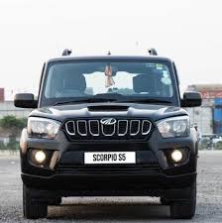 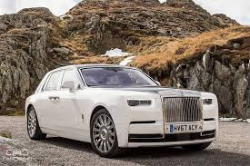

**2 . Related Work in Cars Image Classification :-**We have used the modilenetV2 model for our project.

Because while using resnet50 the accuracy is fluctuating. And the mobilenetv2 gives more accuracy then the resnet50.

MobilenetV2 gives the best result.

We have experimented nearly over 30 times with different hyperparameters by performing hyperparameter tuning and noted the best accuracy result in the hyperparameter tuning spreadsheet.

Out of 30 experiments the hyper parameter which was set to

Epoch == 20

Learning rate == 0.001

Optimizer == optimizer adam

there gives the best result in the mobilenetV2.

I take the images from the kaggle dataset. Those images are in the form of jpg or introverted_png forms. Those images help to identify the name of a character.

This is the references link of cars image dataset

Link :- https://www.kaggle.com/datasets/kshitij192/cars-image-dataset

We used the mobilenetV2 and resnet50.we used the good parameters like Resnet and Mobile netv2 .ResNet is a powerful deep neural network architecture that has revolutionised the field of computer vision by enabling the construction of deeper and more accurate networks.MobileNet-v2 is a convolutional neural network that is 53 layers deep.

**3. Approach:-**

I had taken this dataset from kaggle and after i had extracted and created the folder name after i had started the process. First of all I had to run the code validation_split. This first drive was mounted successfully. The next step is the path to the source and destination folder. After that we have to run some cells that list sub folders, creating duplicate folder structure , listing the files Move x% of files.. By this we had taken our dataset files to test and valid folders now we have completed the first step. Second code is all about saving the best model .in every code common thing is mounting the drive and after that giving the some folder paths those are train and valid and after the running the code.i had used the Resnet giving parameters like Epochs and Learning rates giving variable values but the accuracy levels are very less and highest accuracy is only 81% .I had changed to the mobile net v2 which giving accuracy in 100% . After we give model_path and model_name then the model is saved. After that we get two graphs and one confusion matrix.

The mobilenet we had taken gets good accuracy:

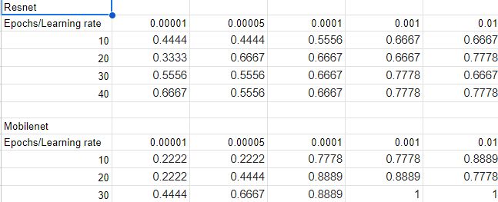

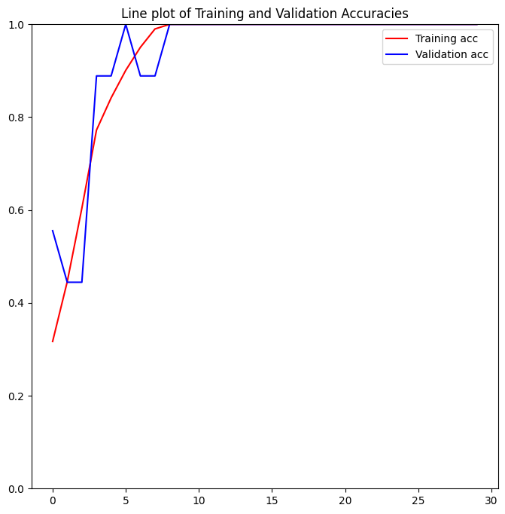 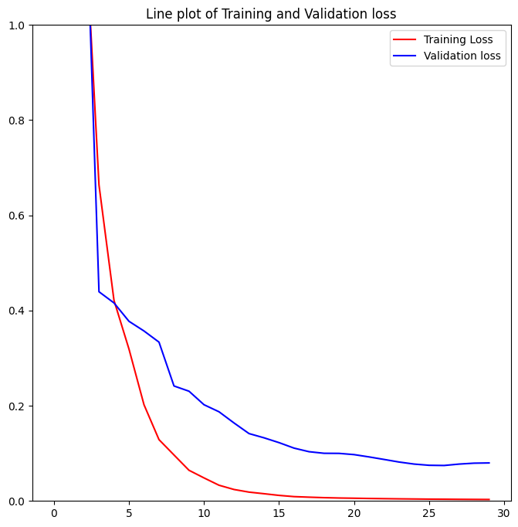

**Fig:1**  **Fig:2**

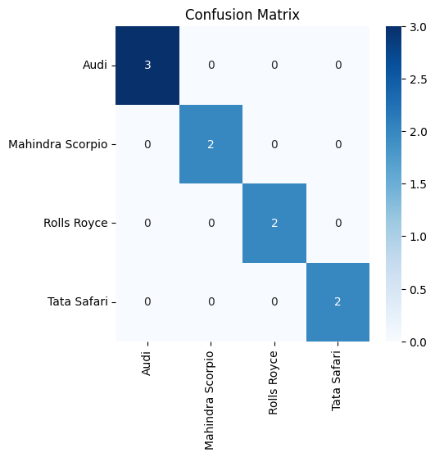  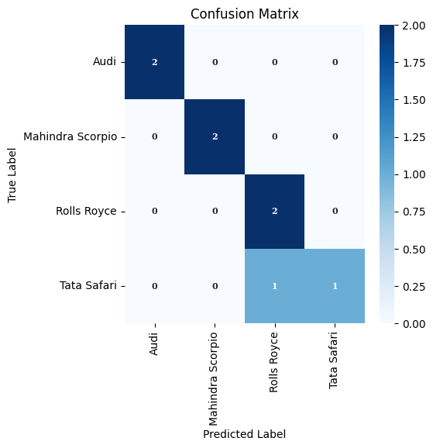

**Fig:3 Fig:4**

In this confusion matrix gives good accuracy.

In the third code tests the image path and it gives the prediction list and confusion matrix and classification report.

**4.RESULT AND DISCUSSION**

In the above figures we observe that accuracy is given in the graphs . It gives a line plot of training and validation accuracies because using the hyper parameters like Resnet and Mobilenet . we trained the model for 10,20,30 epochs and learning rate values 0.00001,0.00005,0.0001,0.001,0.01

It was observed that during the training process the training accuracy and validation accuracy were high at the start and after also become stable increased the epochs

**Fig:1**

We have the line plot of training and validation loss.here in the training process the training loss is almost 0% loss and validation loss were giving 10% loss.

**Fig:2**



In the two confusion matrix also we observed that model has a good performances in terms of accuracy ,sensitivity,specificity ……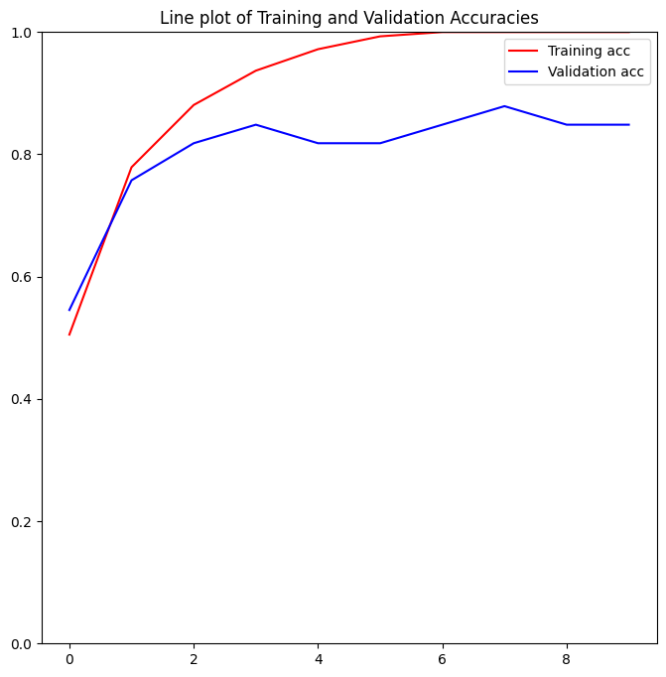

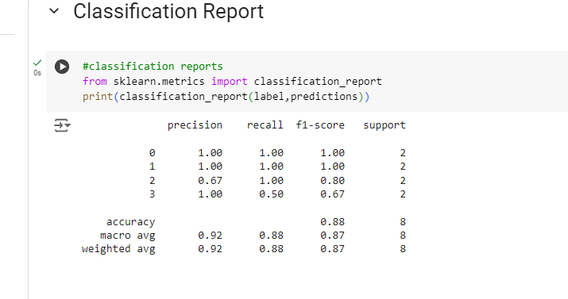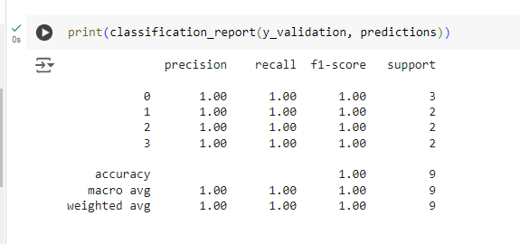

The predictions are also good . they are images of predictions…..

# **Limitations:-**

* As we did our project on a small dataset the accuracy is quite good.

**5.Conclusion**

In this work, cars were automatically classified into groups based on the standard using a built convolutional neural network model. The research was performed using the open source cars dataset and the findings indicated that the developed model performed excellently in terms of accuracy, sensitivity, specificity .

The study relied on a convolutional neural network model for automatic feature extraction and classification, it might not capture the specific features of cars that are relevant for behavioural classifications. Hence, this work can only classify the cars correctly. it was trained with at high accuracy

Automated Car Damage Assessment (CDA) systems hold significant potential for societal and economic benefits. A well-designed CDA system can greatly enhance online evaluation efficiency and substantially reduce human effort. This eliminates the need for vehicle owners to physically transport their cars to insurance companies, allowing quick access to evaluation results. This not only alleviates traffic congestion but also contributes to overall cost reduction for society. Unfortunately, the lack of comprehensive datasets for analysis and study has hindered research progress in vehicle damage assessment.

**References**

**<>LINK:-**[**https://www.tandfonline.com/doi/full/10.1080/24751839.2024.2367387**](https://www.tandfonline.com/doi/full/10.1080/24751839.2024.2367387)

**<>LINK:-**[**https://www.kaggle.com/datasets/kshitij192/cars-image-dataset**](https://www.kaggle.com/datasets/kshitij192/cars-image-dataset)